**Tutorial Activity 1 – Protecting a Discovery. Consider the following scenario, What would you do?**

**Update on Project α: Solar Panel Pastes**

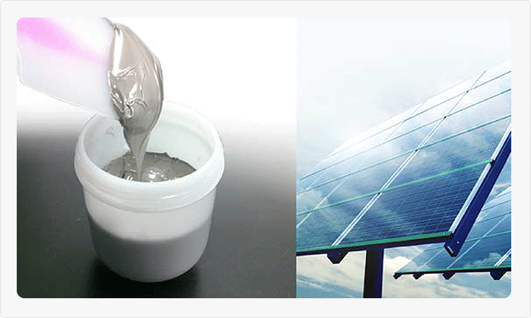 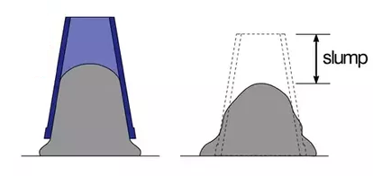

The solar panel paste project has been progressing well in recent months. In particular, our recent decision to hire researchers with a more diverse range of research experience seems to be paying off.

Solar panels use an array of conducting wires to take current off photovoltaic modules which generate electricity. Such wires are often produced by screen-printing of conductive pastes onto a silicon wafer. In such processes, the paste is squeezed through a mesh to provide the desired wire pattern on the silicon wafer, and then solidified/dried.

However conductive efficiency depends greatly on the shape and topography of the printed pastes, with slumping and spreading of printed pastes prior to drying being a well-known problem leading to poor conductive performance.

Our new recruit, Ron Gastromy, has found that by combining silver particles with egg white proteins and a liquid carrier, and beating the mixture thoroughly, a conductive paste is produced which, on screen printing, retains its peak shape and resists slumping and spreading during the drying/solidification process. The resulting wires are highly conductive, and 45% more efficient than the current leading commercial products.

We are excited about this development, which could be lucrative, but are also concerned about whether it will be patentable? The use of conductive silver particles in solar panel pastes is standard in the field. Prior to joining us, Dr Gastromy worked as a pastry chef in Paris, and he advises that it has been commonplace for centuries to use egg whites (which include egg white proteins) and beating processes to produce meringues and similar foods which hold their shape.

**Edna Gise, Director of Renewable Technologies inc.**

**What strategy would you use to protect this discovery ? Is this patentable ?**

**Why ?**

**What are some potential Claims ?**

**Tutorial Activity Two – Technology Management Strategy**

Your group leads a small organisation which has developed a way of producing a new generation of carbon fibre composite rock-bolts at a significantly reduced price. The bolts have a number of advantages over steel rock-bolts in that they do not rust, have a higher modulus and self-fuse into the rock negating the need for adhesives. The carbon fibre rock bolts can also be readily cut through should re-work be required without damage to equipment which may occur with the use of steel rock-bolts.

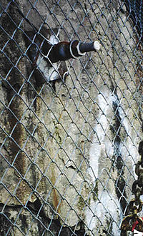 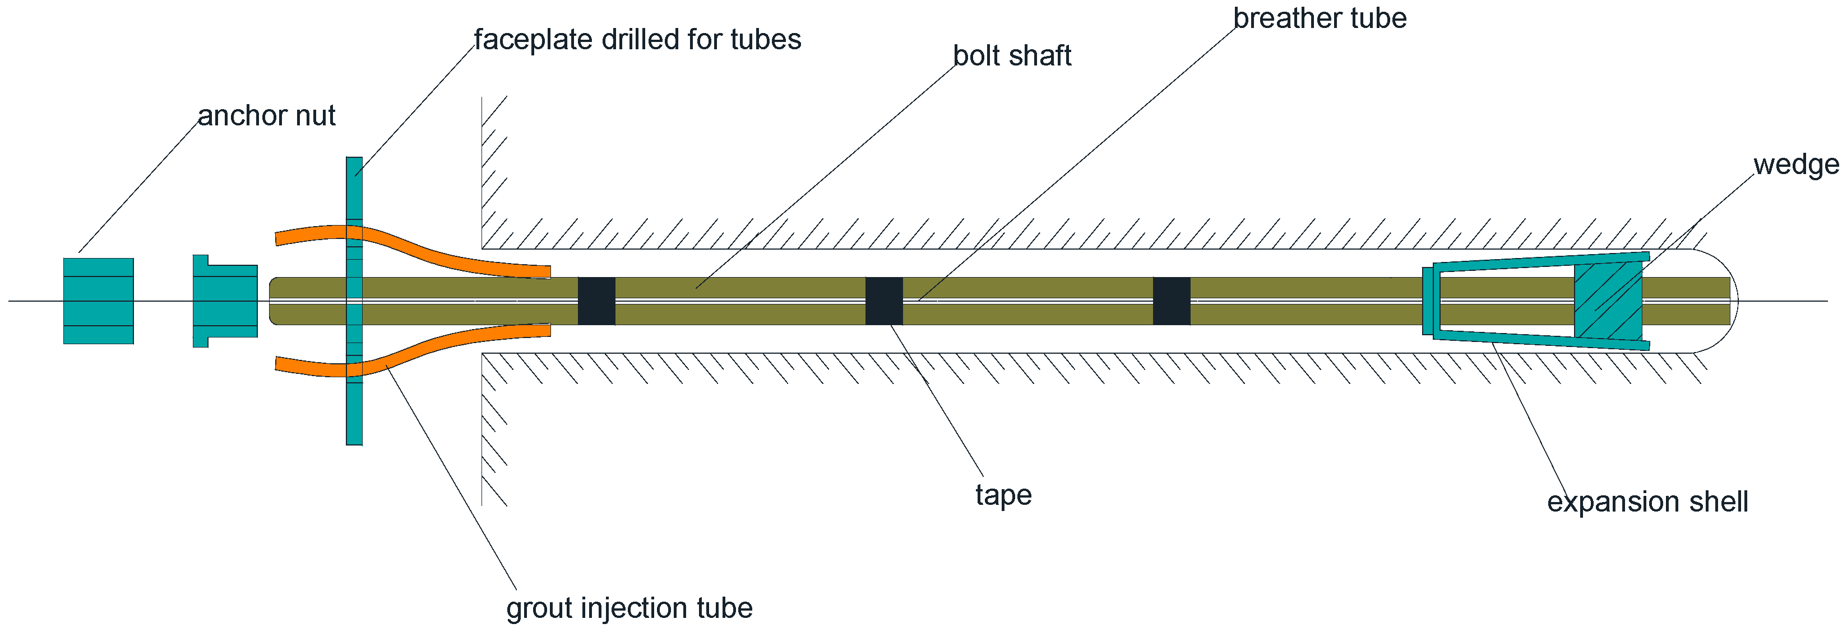

Conventional Rockbolt In Operation and Schematic

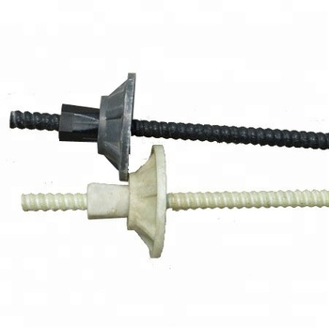

Fibre Reinforced Plastic Rockbolt

You are considering a strategy for the management of this new discovery and using it to tender for major high value tunnelling projects amongst other initiatives. Defend a strategy to do so considering the Heilmeier Catechism.

1. What are you trying to do? Articulate your objectives using absolutely no jargon. What is the problem? Why is it hard?
2. How is it done today, and what are the limits of current practice?
3. What's new in your approach and why do you think it will be successful?
4. Who cares? Should mention key stakeholders.
5. If you're successful, what difference will it make? What impact will success have? How will it be measured?
6. What are the risks and the payoffs?
7. How much will it cost? [Describe the process you would take to get this information]
8. How long will it take? [What key activities would you need to consider here to implement the new technology]
9. What are the midterm and final "exams" to check for success? How will progress be measured?